|  |  |
| --- | --- |
| **Name:** | Bodhisatya Ghosh |
| **Branch:** | CSE – Data Science |
| **Batch:** | B |
| **Course:** | Soft Computing |
| **Experiment no:** | 7 |

**Aim:** To implement fuzzy set and fuzzy relations for a given problem.

**Theory:** Linear regression analysis is used to predict the value of a variable based on the value of another variable. The variable you want to predict is called the dependent variable. The variable you are using to predict the other variable's value is called the independent variable.

This form of analysis estimates the coefficients of the linear equation, involving one or more independent variables that best predict the value of the dependent variable. Linear regression fits a straight line or surface that minimizes the discrepancies between predicted and actual output values. There are simple linear regression calculators that use a “least squares” method to discover the best-fit line for a set of paired data. You then estimate the value of X (dependent variable) from Y (independent variable).

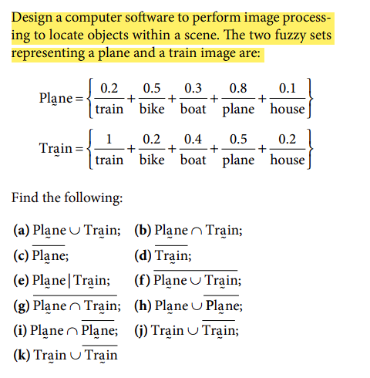

**Program:** 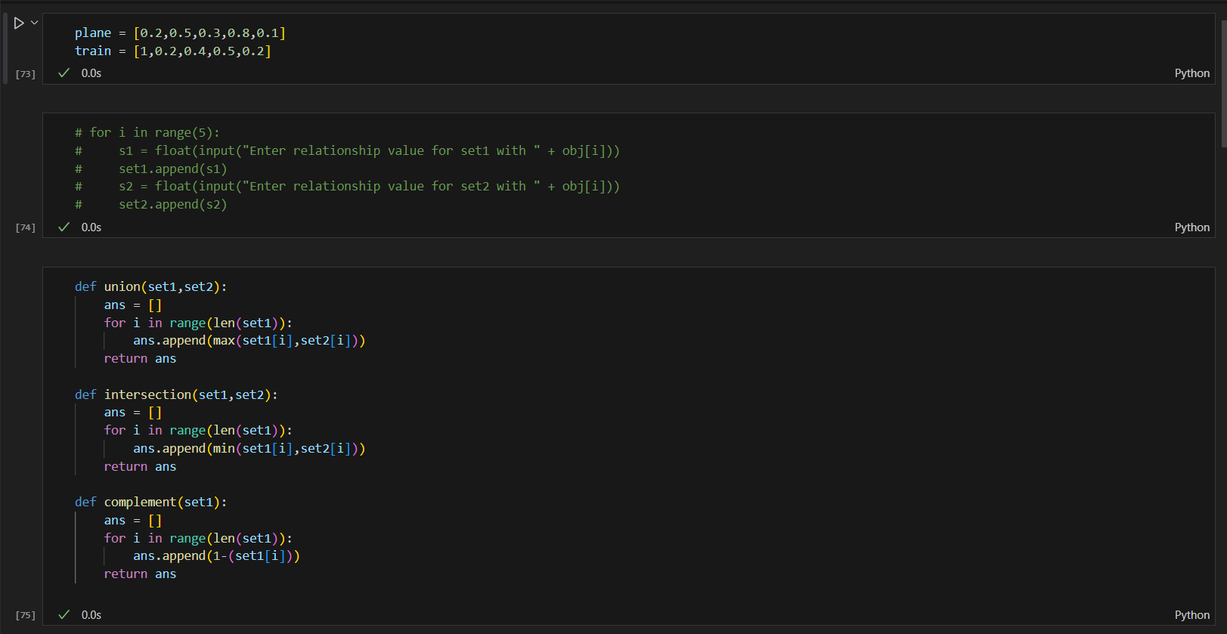

**Results:**

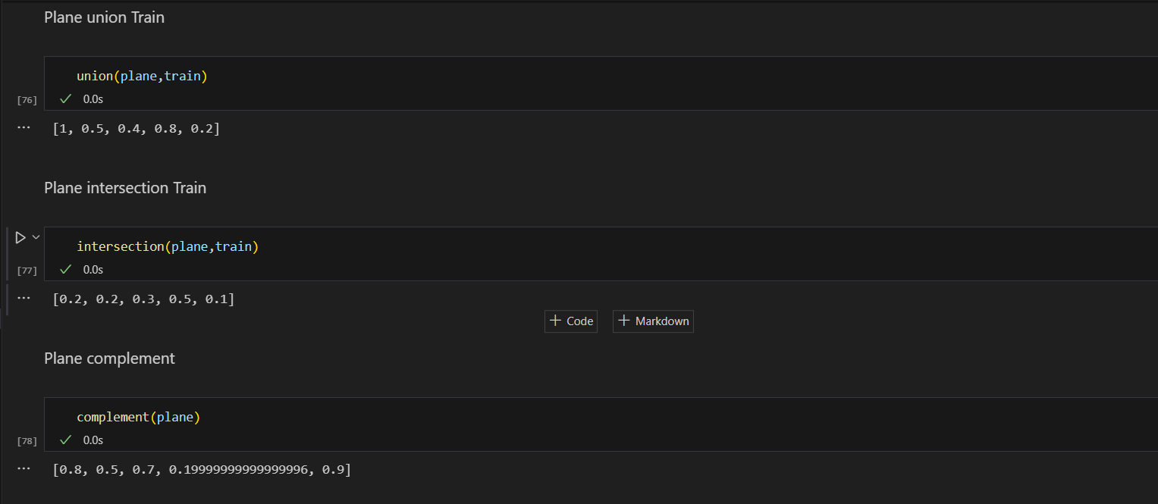

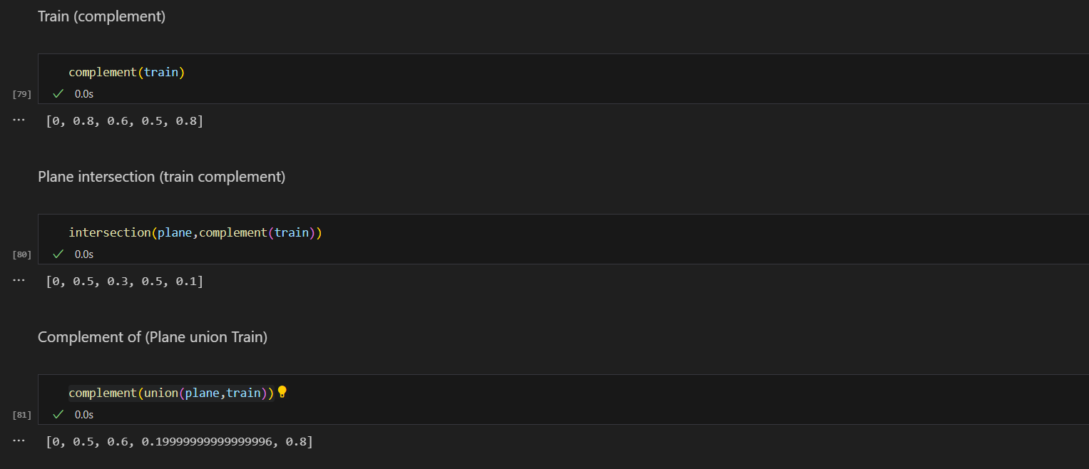

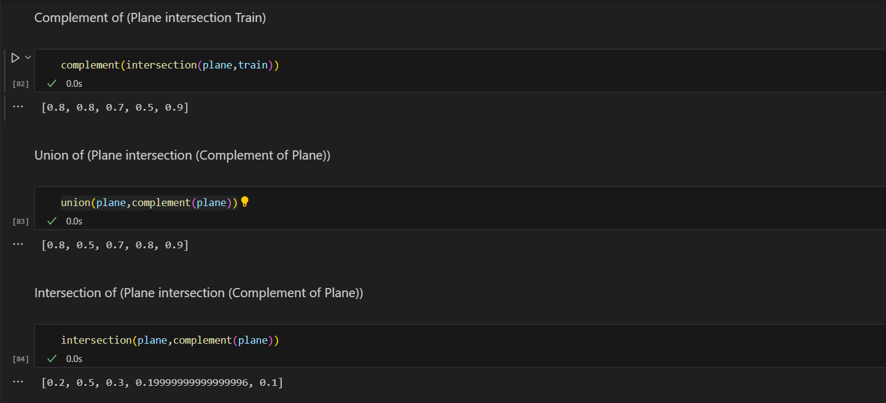

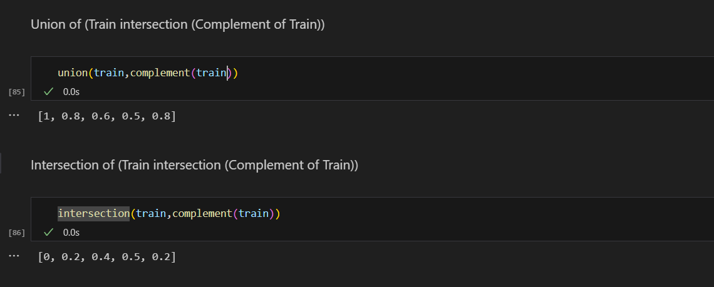

**CONCLUSION: -** In this experiment we studied about fuzzy sets and fuzzy relations